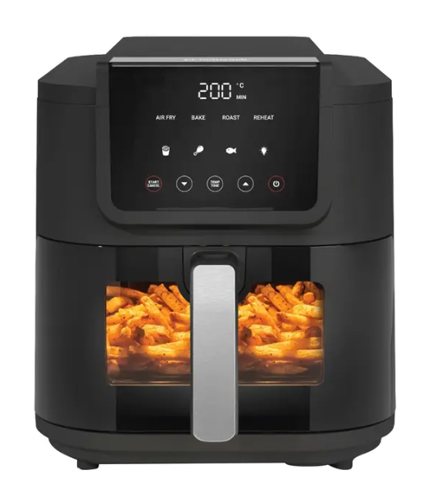

LG Air Fryer
Rs.30,000
An LG air fryer is usually integrated into LG ovens or smart cooking ranges rather than standalone units. It uses advanced convection (hot air circulation) to cook food evenly with little or no oil, offering healthier and faster cooking.

Specifications
- Model: AF500
- Type: Air Fryer
- Power: ~1500W – 2500W (depending on oven size)
- Capacity: 3.5L – 5L

Key Features
- Advanced Convection
- Even Cooking
- Easy to Clean
- Smart Cooking

